**“CS5785 Homework 4”**

**Submitted as part of Homework**

**required for**

**Applied Machine Learning (CS5785)**

**SUBMITTED BY**

TANUJ AHUJA – ta364

JAMIE YU – jky32

**SUBMITTED TO**

***Cornell Tech, Cornell University***

**2 W Loop Road,**

**New York, NY 10044**



**PROGRAMMING EXCERCISES**

**Q1.** **Approximating images with neural networks**

Q**1(a).** Describe the structure of the network. How many layers does this network have? What is the purpose of each layer?

**Ans1(a).** The network has following structure –

* + 1. Input Layer: Receives 2 inputs (x,y) in form of 1x1x2 matrix
    2. Hidden Layers: 7 Fully Connected Hidden Layers (used for image feature extraction) with ReLU activation. Rectified Linear Units here provide for sparse representation as well as a reduced likelihood for vanishing gradient descent therefore allowing for quicker and more precise computation.
    3. Output Layer: Uses a regression layer with three outputs for (r,g,b) color value.

All in all, the network maps 2-dimensional pixel coordinates to 3-dimensional color scheme values.

**Q1(b).** What does “Loss” mean here? What is the actual loss function? You may need to consult the source code, which is available on Github.

**Ans1(b).** “Loss” here means **L2 regression cost**. L2-norm loss function is also known as *least squares error (LSE).* It is basically minimizing the sum of the square of the differences **(S)** between the target value (**Yi**) and the estimated values (**Xi)**The code below penalizes , where **x** is its input and **y** is the user-provided array of “correct” values.  
**y** is a list of size **num_inputs** or it can be a number if only one value is regressed.

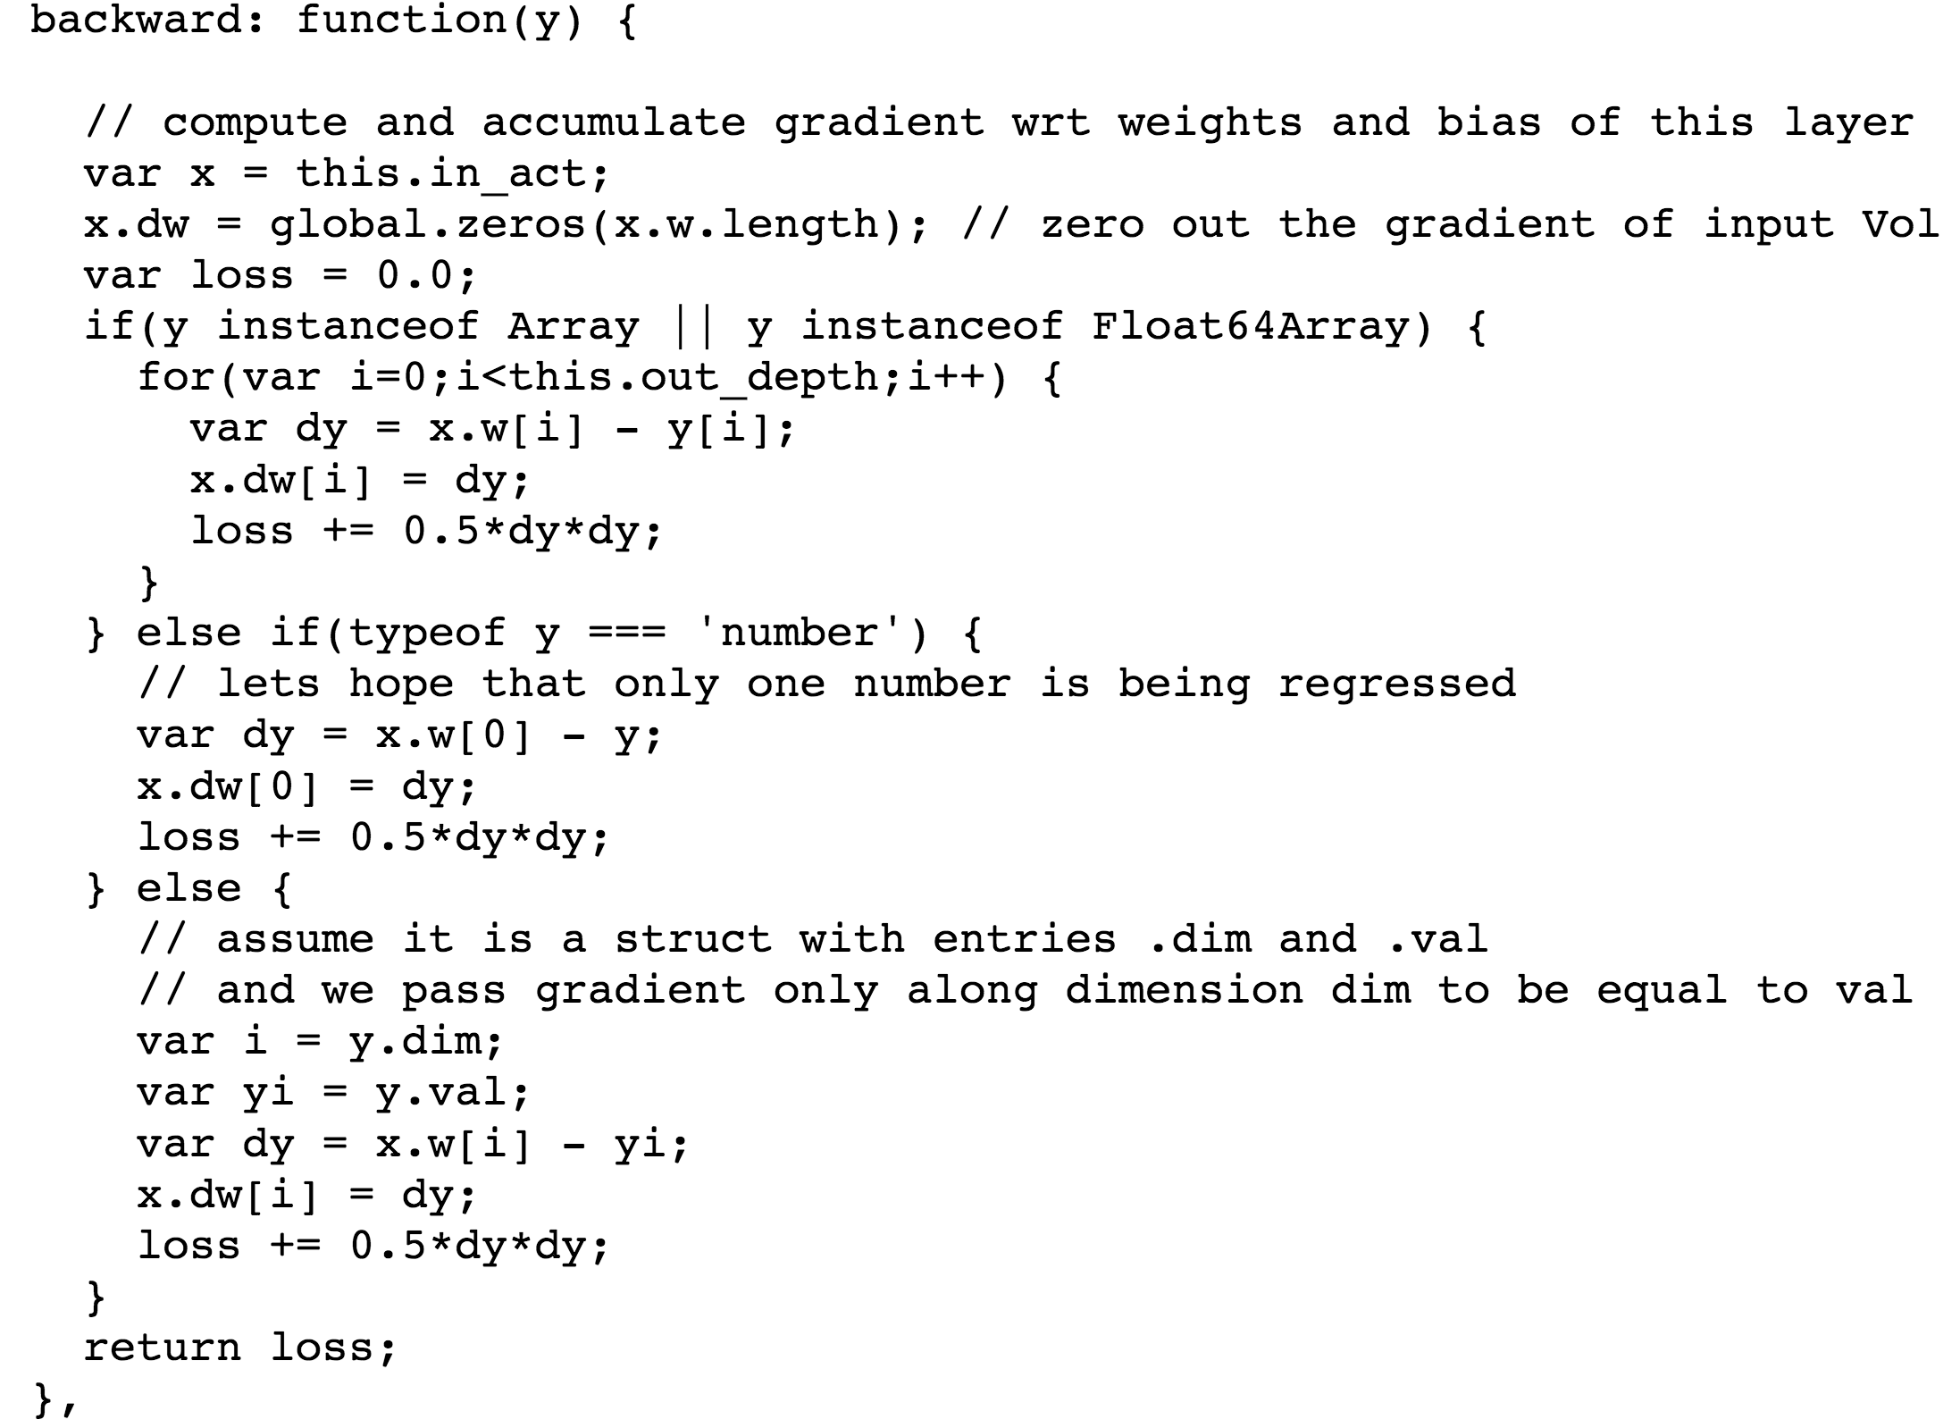

**Q1(c).** Plot the loss over time, after letting it run for 5,000 iterations. How good does the network eventually get?

**Ans1(c).** We used console based javascript code (given below) to sample “Loss” and “Iteration” values at every 500 iterations until the total iterations reached 5000.  
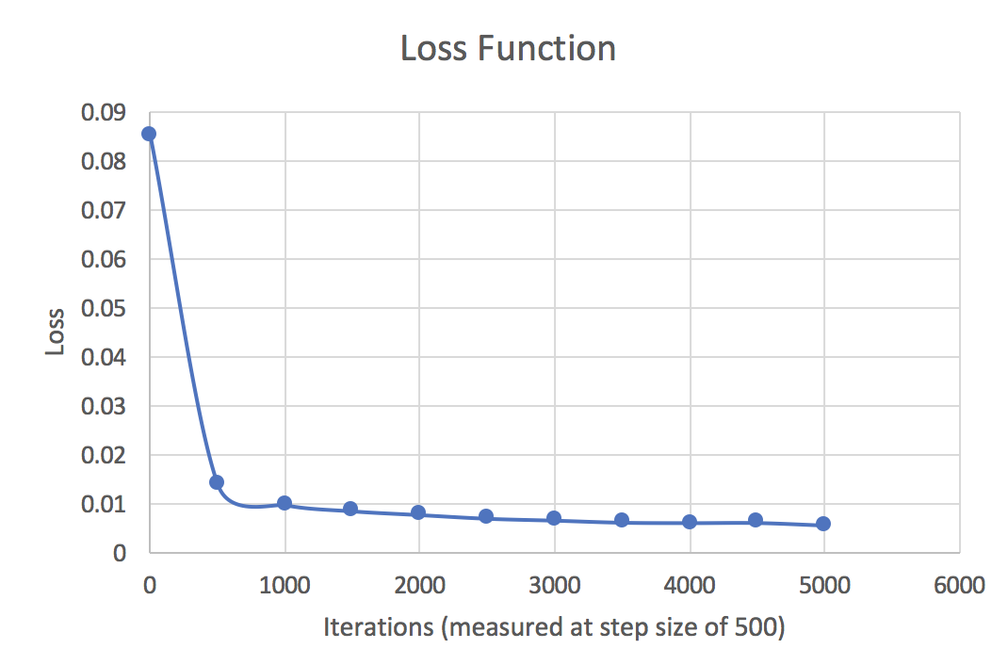

As can be seen from the graph, the network eventually gets better in terms of loss function as it is made to run through more iterations. However, this converging loss function becomes somewhat linear after a particular number of iterations (as can be seen from the graph).

**Q1(d).** Can you make the network converge to a lower loss function by lowering the learning rate every 1,000 iterations? (Some learning rate schedules, for example, halve the learning rate every n iterations. Does this technique let the network converge to a lower training loss?)

**Ans1(d).** We halved the learning rate every 1000 iterations and compared it to the case when the learning rate was kept fixed (= 0.01) and it appears that this technique lets the network converge to a lower loss function.

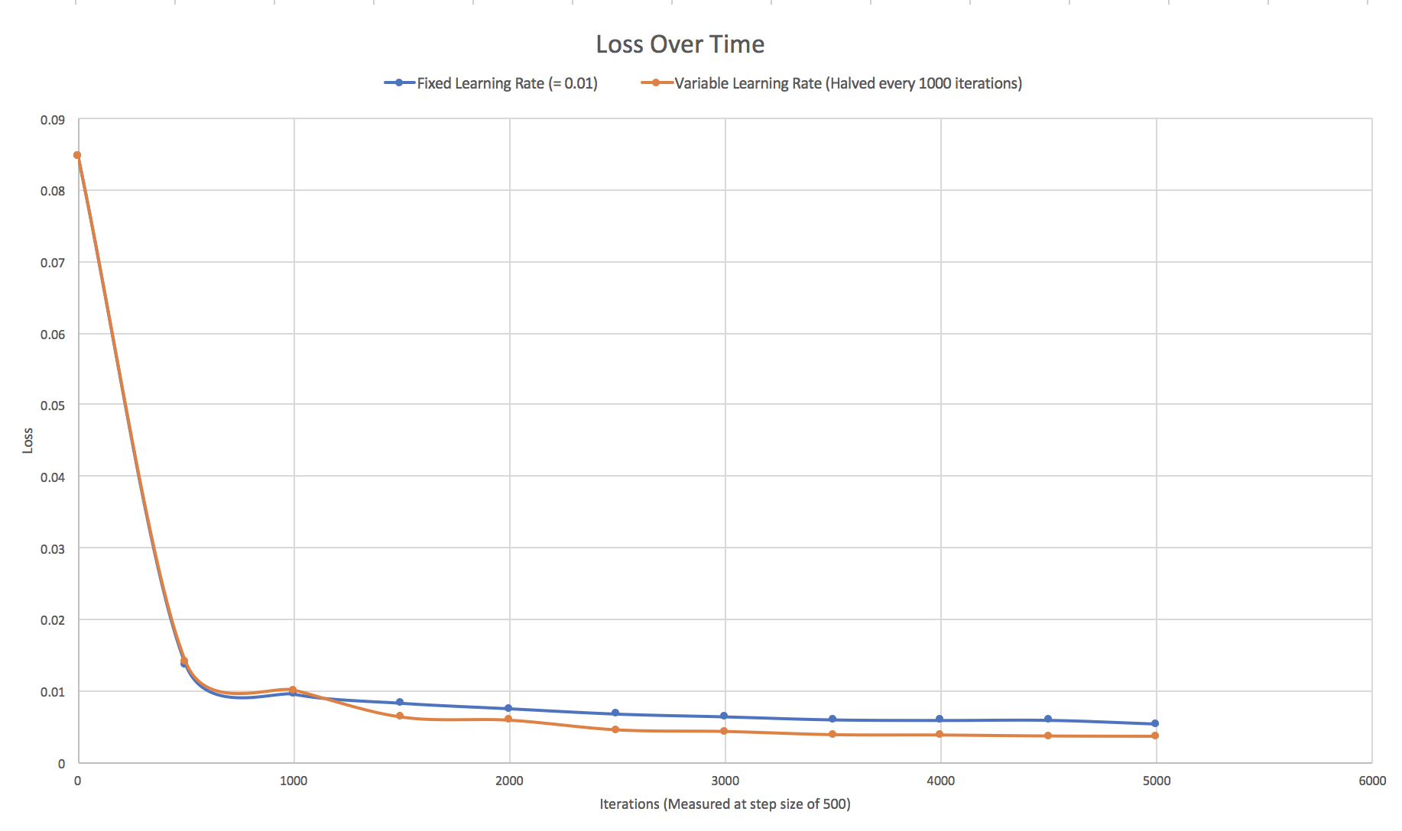

**Q1(e).** Lesion study. The text box contains a small snippet of Javascript code that initializes the network. You can change the network structure by clicking the “Reload network” button, which simply evaluates the code. Let’s perform some brain surgery: Try commenting out each layer, one by one. Report some results: How many layers can you drop before the accuracy drops below a useful value? How few hidden units can you get away with before quality drops noticeably?

**Ans1(e).**

Original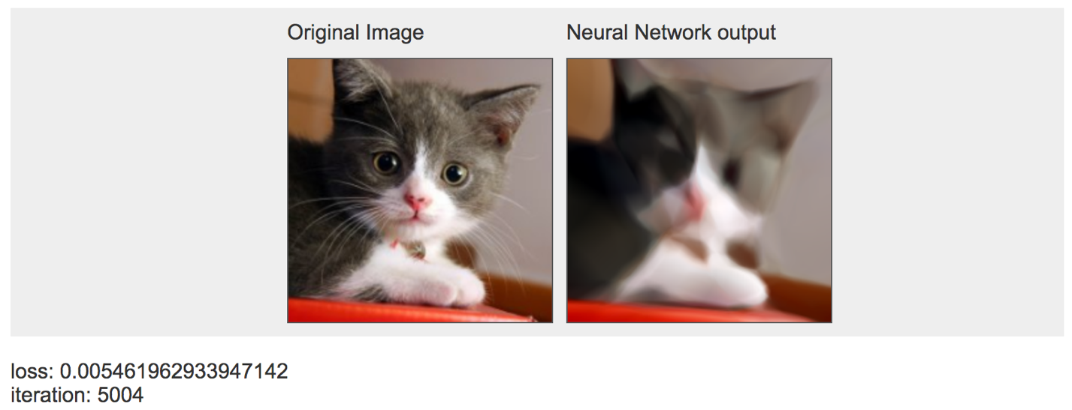

3 Layers Commented Out

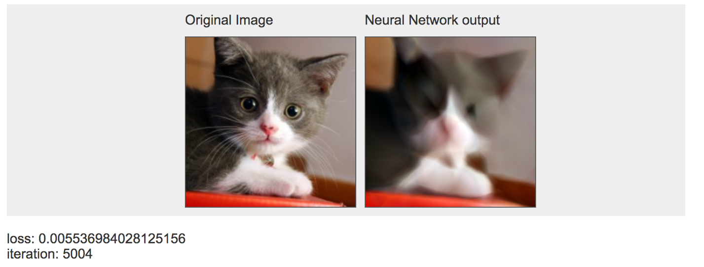

4 Layers Commented Out

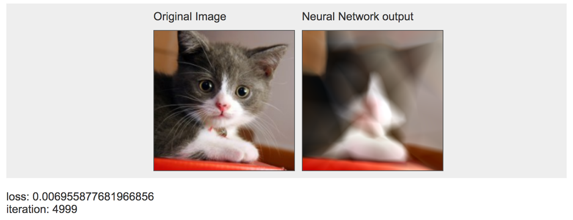

5 Layers Commented Out

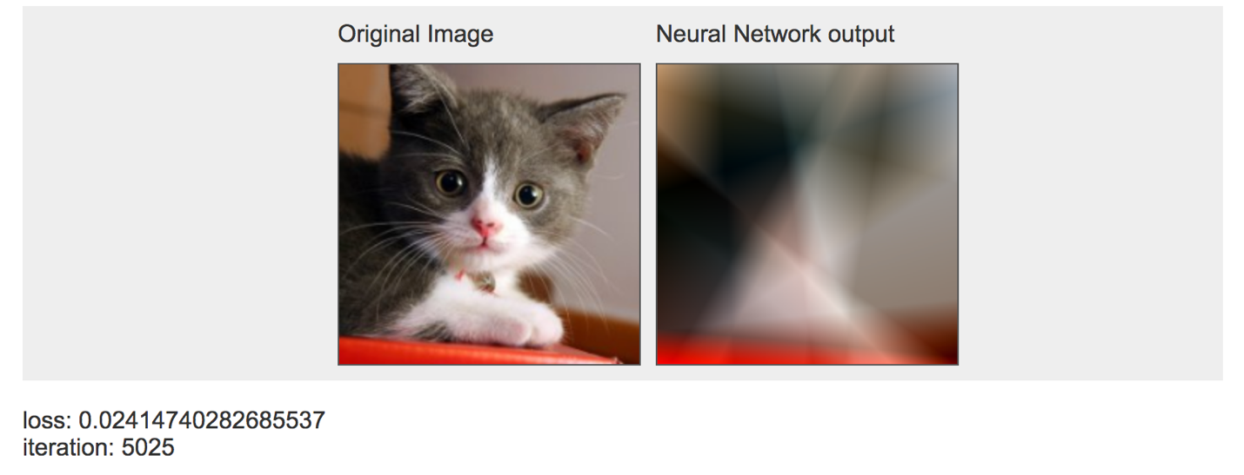

6 Layers Commented Out

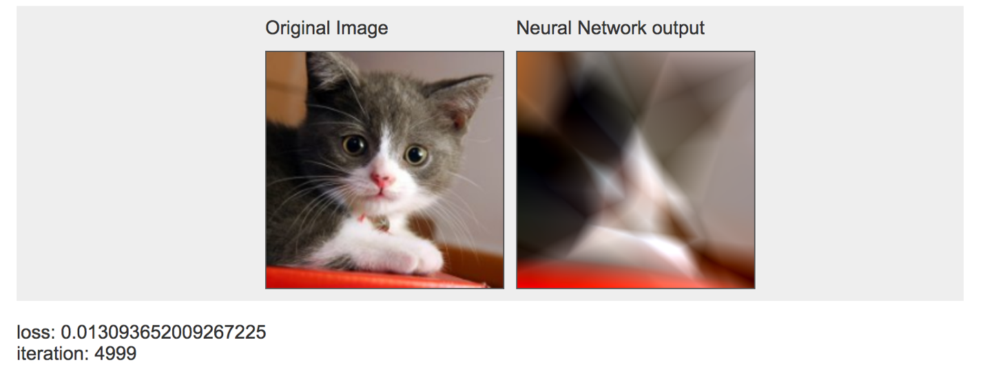

7 Layers Commented Out

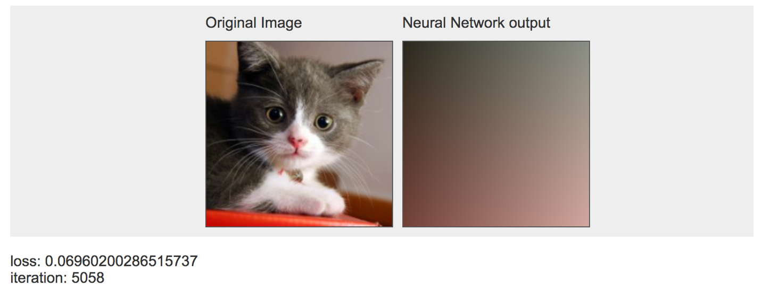

There was a significant drop in image quality after 5 layers were commented out. If even more layers were hidden, the image quality got significantly worse with the outline becoming indiscernible after hiding all 7 layers.

**Q1(f).** Try adding a few layers by copy+pasting lines in the network definition. Can you noticeably increase the accuracy of the network?

**Ans1(f).** We increased the layers from 7 to 11 but there was no noticeable change in accuracy.

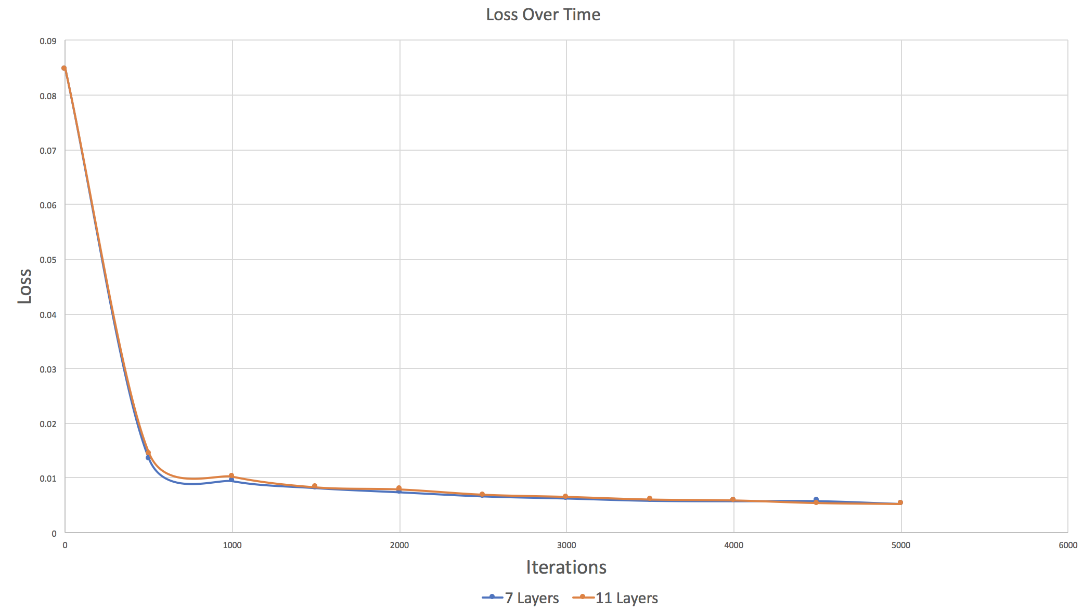

**Q2.** **Random Forests for image approximation**

**Q2(a).** Start with an image of the Mona Lisa. If you don’t like the Mona Lisa, pick another interesting image of your choice.

**Ans2(a).** Chose to work with the Mona Lisa image. We used PIL(Python Imaging Library) to load the image. We then converted it to a numpy array so it could be read and visualized by matplotlib.

*Code:*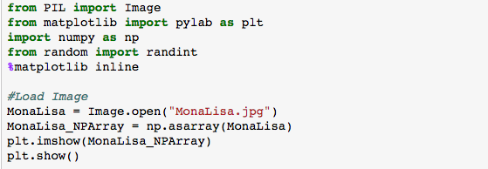

*Output:*



**Q2(b).** Preprocessing the input. To build your “training set,” uniformly sample 5,000 random(*x*,*y*) coordinate locations.

• What other preprocessing steps are necessary for random forests inputs? Describe them, implement them, and justify your decisions. In particular, do you need to perform mean subtraction, standardization, or unit-normalization?

**Ans2(b).**

*Code to uniformly sample 5,000 random(x,y) coordinates:*

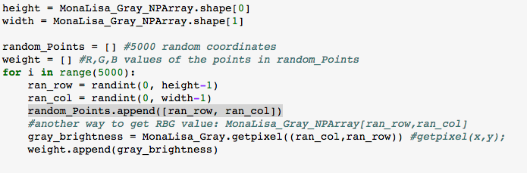

*Other preprocessing steps?*

One of the benefits of decision trees is that continuous input data does not require any significant preprocessing. Results should be consistent regardless of any scaling, mean subtraction, or unit normalization since the trees can choose equivalent splitting points. As long as the relative order of values of the data does not change, a good preprocessing method for decision trees is whatever is most convenient for the dataset (i.e. visually changing the dataset, or scaling down to work with easier numbers, etc.)

**Q2(c).** Preprocessing the output. Sample pixel values at each of the given coordinate locations. Each pixel contains red, green, and blue intensity values, so decide how you want to handle this. There are several options available to you:

* Convert the image to grayscale
* Regress all three values at once, so your function maps (*x*,*y*) coordinates to (*r*,*g*,*b*) values: *f* : R2 → R3
* Learn a different function for each channel, *fRed* :R2 →R, and likewise for *fGreen*, *fBlue*.  Note that you may need to rescale the pixel intensities to lie between 0.0 and 1.0. (The default for pixel values may be between 0 and 255, but your image library may have different defaults.)  What other preprocessing steps are necessary for random regression forest outputs? Describe them, implement them, and justify your decisions.

**Ans2(c).**

*Code:*

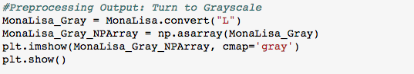

*Output:*



We chose to preprocess the output by transforming the image to grayscale. We did this to diminish the amount of signal-to-noise: color information was not necessary in performing the random forest analysis so the RGB information can be considered unnecessary information or noise. In addition, getting rid of this information in favor of the simper grayscale luminescence reduces the amount of information that needs to be processed and thus reduces the amount of computational load on the computer.

*Source: https://www.quora.com/In-image-processing-applications-why-do-we-convert-from-RGB-to-Grayscale*

**Q2(d).** To build the final image, for each pixel of the output, feed the pixel coordinate through the random forest and color the resulting pixel with the output prediction. You can then use imshow to view the result. (If you are using grayscale, try imshow(Y, cmap=’gray’) to avoid fake-coloring). You may use any implementation of random forests, but you should understand the implementation and you must cite your sources.

**Ans2(d).**

*Code:*

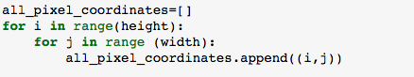

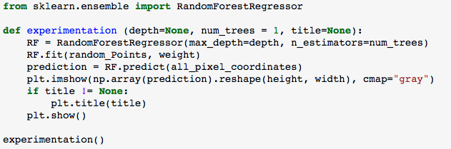

*Output:*



**Q2(e). Experimentation**

1. Repeat the experiment for a random forest containing a single decision tree, but with depths 1, 2, 3, 5, 10, and 15. How does depth impact the result? Describe in detail why.

*Code:*

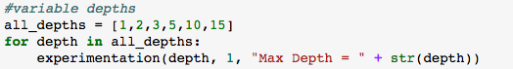

*Output:*

** **

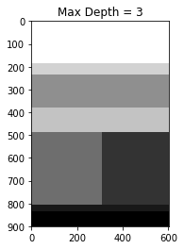 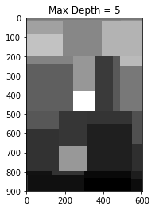

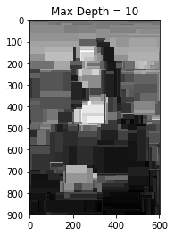 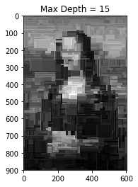

*Justification:*

The ‘max_depth’ parameter in scikit-learn’s Random Forest Algorithm controls the maximum depth of the tree. In other words, the tree will stop growing once it reach the maximum depth; this controls the complexity of the decision tree.

With a depth of 1, the decision tree sorts the tree into two groups: black and white. As the depth increases, the number of groups the tree sorts into also exponentially increases. This is because with a greater depth, the decision tree has exponentially more nodes: with a depth of 2 the tree has 4 nodes, depth of 3 has 8 nodes, etc. A visual example of this can be seen from the image of a binary tree below:

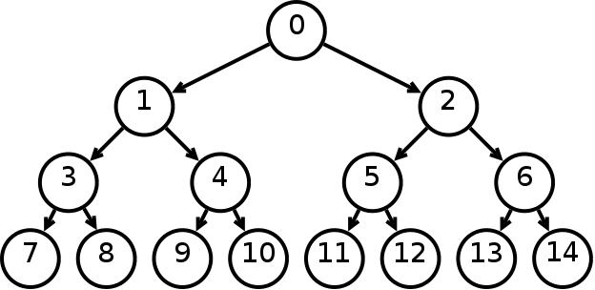

1. Repeat the experiment for a random forest of depth 7, but with number of trees equal to 1, 3, 5, 10, and 100. How does the number of trees impact the result? Describe in detail why.

*Code:*

**

*Output:*

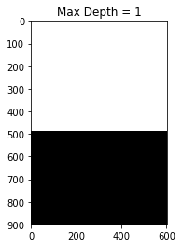 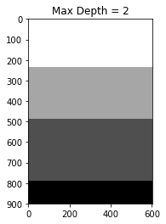    

*Justification:*

As the depth is maintained but the number of decision trees increases, we see that the number of trees positively correlates with how smooth the image is. In other words, as the number of trees increases, the image becomes smoother.

This is because random forest is an example of an ensemble learner built on decision trees. Each tree is a classifier that is trained independently of other trees. Each tree also randomly selects a subset of features/data and classifies over a number of nodes. The result is the predictions provided by the leaf nodes of the tree. A majority vote is taken of all the decision trees to create an accurate and stable final prediction.

As the number of trees increase, the amount of data that each tree is responsible for classifying decreases which allows for better predictions to be made at a more precise level. This is why as the number of trees increase, the image becomes smoother.

*Source:* [*https://jakevdp.github.io/PythonDataScienceHandbook/05.08-random-forests.html*](https://jakevdp.github.io/PythonDataScienceHandbook/05.08-random-forests.html)

*Source: http://alifar76.github.io/sklearn-metrics/*

1. As a simple base line, repeat the experiment using a *k*-NN regressor, for *k*=1. This means that every pixel in the output will equal the nearest pixel from the “training set.” Compare and contrast the outlook: why does this look the way it does?

*Code:*

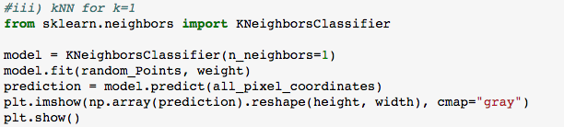

*Output:*

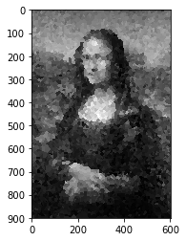

*Justification:*

Compared to the images predicted by Random Forest, the image predicted by kNN is subdivided into smaller, circular “blobs” rather than rectangular subsections found by Random Forest. In kNN, each pixel’s class is determined by the majority class of the pixels closest to it, or the majority class of its k nearest neighbors. This results in a circular shape. In Random Forest, however, decision trees split up the data by a subsection of features which visually look like a rectangular partition. Pixels are classified and filtered through the model and lands in one of the rectangles partitioned by the decision trees. This is why Random Forest provides more boxy decision boundaries which is exhibited by the rectangles in the image. *Source:* [*https://machinelearningmastery.com/classification-and-regression-trees-for-machine-learning/*](https://machinelearningmastery.com/classification-and-regression-trees-for-machine-learning/)

1. Experiment with different pruning strategies of your choice.

*Justification:*

Pruning is performed on a tree by deleting the child nodes of a branch node, thereby changing the model. This is required in decision trees as decision trees can always classify training examples perfectly by splitting the data until each node contains 1 example. In the process of doing this, the tree can overfit to the training data and not do well on the testing data.

Thus, pruning is needed to get rid of overfitting in decision trees. However, random forests don’t need to be pruned because each individual tree bags a specific, random subset of data and thus individual trees are not correlated with each other. This also deals with the problem of overfitting. Because individual trees have already gone through bagging, there is less of a need to prune random forests which is an ensemble of individual decision trees.

In addition, we trained our data on 5,000 randomly selected pixel coordinates; the randomness of the training data as well as the large number of pixel coordinates deals with the problem of overfitting enough so that pruning would be more computationally costly in our Random Forest model than it is worth.

*Source: https://stats.stackexchange.com/questions/36298/why-is-pruning-not-needed-for-random-forest-trees*

**Q2(f). Analysis**

1. *What is the decision rule at each split point? Write down the 1-line formula for the split point at the root node for one the trained decision trees inside the forest. Feel free to define any variables you need.*



The above image was outputted by a Random Forest algorithm that had 1 trained decision tree with a depth of 1 in the forest. The decision tree classified each pixel by taking the coordinates of the pixel(x,y), filtering the pixel through the decision rule, and then outputting a child node(either the left or right node) that determines the class of the pixel (or the color/brightness).

Let’s assume that in the decision tree for the above image, the left node outputs a class of the color white and the right node outputs a class of the color black. In the above image, it is clear that the decision boundary was a value of ~500. In other words, if the y-value of pixel coordinates was above ~500, the pixel was classified to the left node (color white). If not (if the y-value was below ~500), the pixel was classified to the right node (color black). This is the decision rule.

In python this can be written as:

return leftNode if y-value > 500 else return rightNode

1. *Why does the resulting image look like the way it does? What shape are the patches of color, and how are they arranged?*

In Random Forest, decision trees split up the data by taking a subsection of features; this visually looks like a rectangular partition. Pixels are classified and filtered through the model and lands in one of the rectangles partitioned by the decision trees. This is why Random Forest provides more boxy decision boundaries which is exhibited by the rectangles in the image.

In the case of the example/image in part a), since there is a single decision tree with a depth of 1 there are only two leaf nodes or two possible classes for each pixel coordinate. Since there are only two possible classes or colors, the resulting colors are black and white which are the two most representative colors. As the number of leaf nodes increase, the number of possible classes/colors increase, resulting in more variance in possible colors(i.e. different shades of gray).

1. *Straightforward: How many patches of color may be in the resulting image if the forest contains a single decision tree? Define any variables you need.*



Each leaf node represents a different class or in our case, a different color/brightness. If there is a single decision tree, the number of different classes or colors are determined by the depth of this tree or 2 raised to the power of the value of depth(2^depth). As the depth increases the number of nodes exponentially increase which we can see in the image above.

1. *Tricky: How many patches of color might be in the resulting image if the forest contains n decision trees? Define any variables you need.*

A single decision tree has 2^depth number of leaf nodes or color classes. If the forest contains n decision trees, then there are N*2^depth possible color classes. However, even if there are multiple possible color classes, that does not mean that every leaf node is unique as the decision trees could have overlap in the features that they are responsible for classifying. Therefore N*2^depth is the upper bound for the number of possible color classes but depending on the number of unique leaf nodes (or the amount overlapping data that each decision tree is responsible for classifying), the resulting number of patches of color is probably less.

**WRITTEN EXCERCISES**

